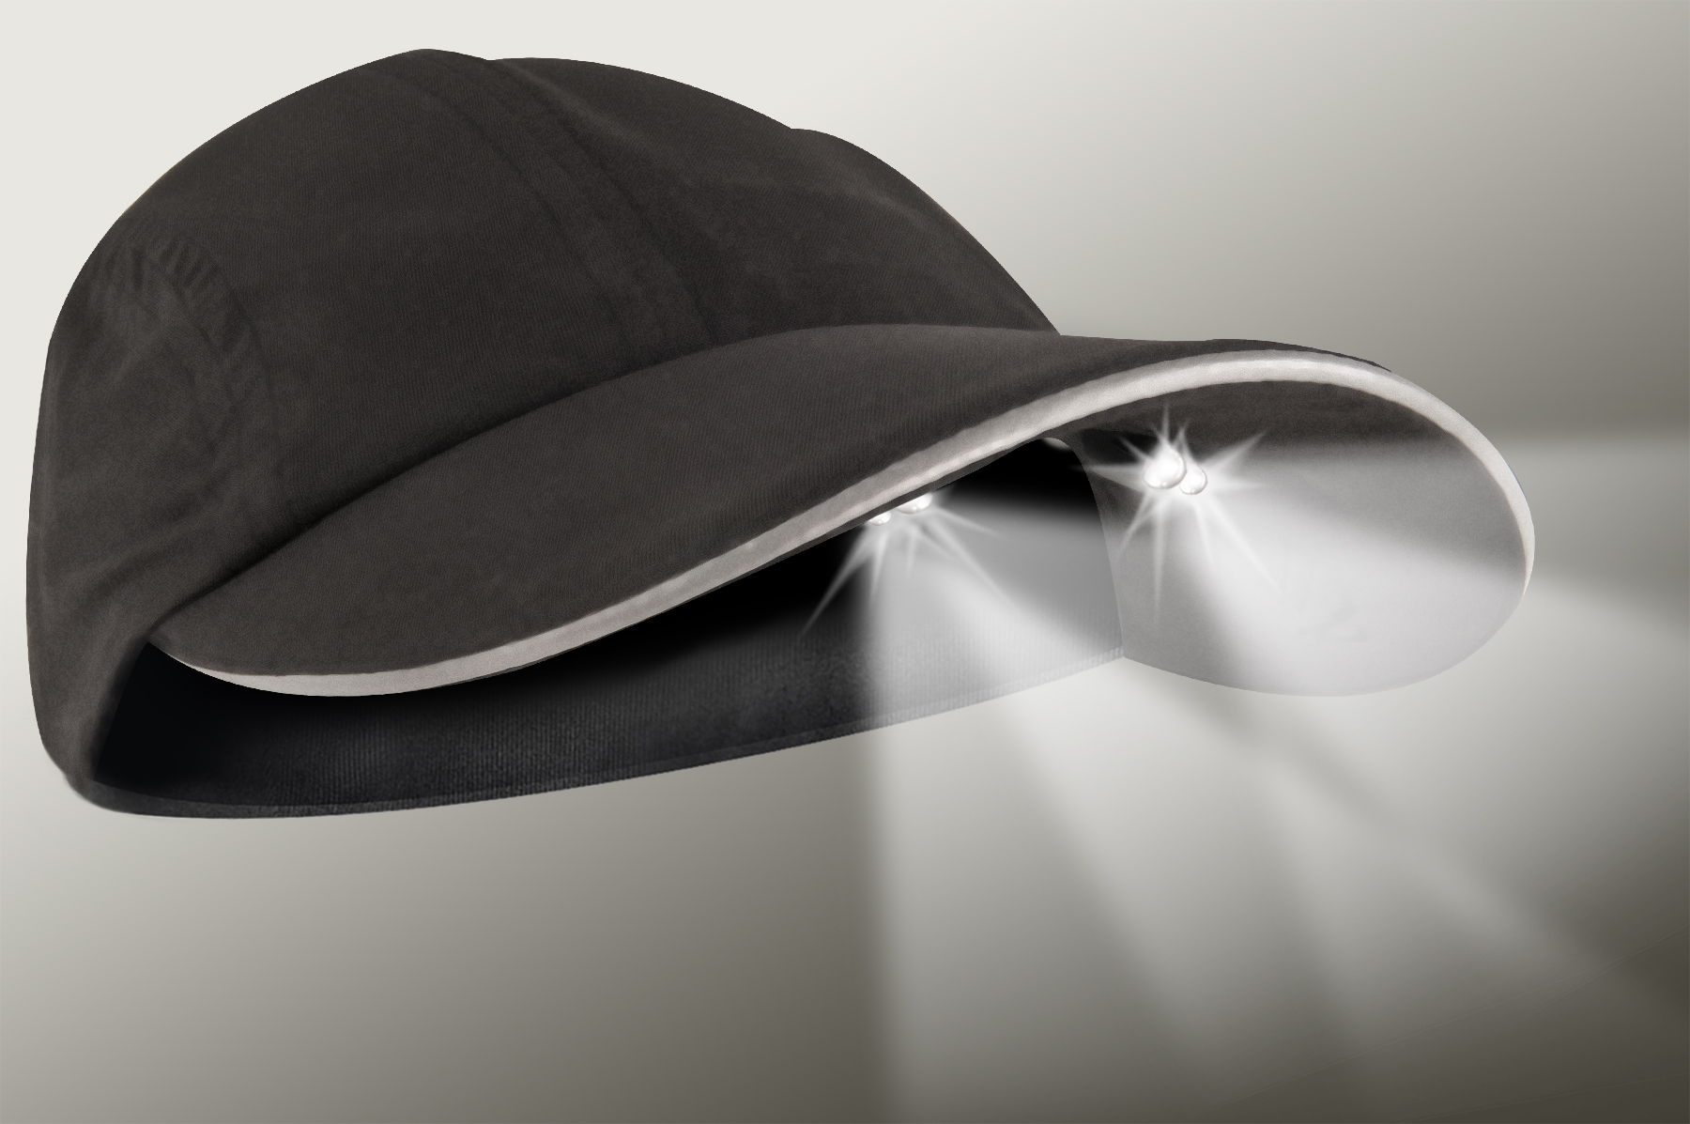
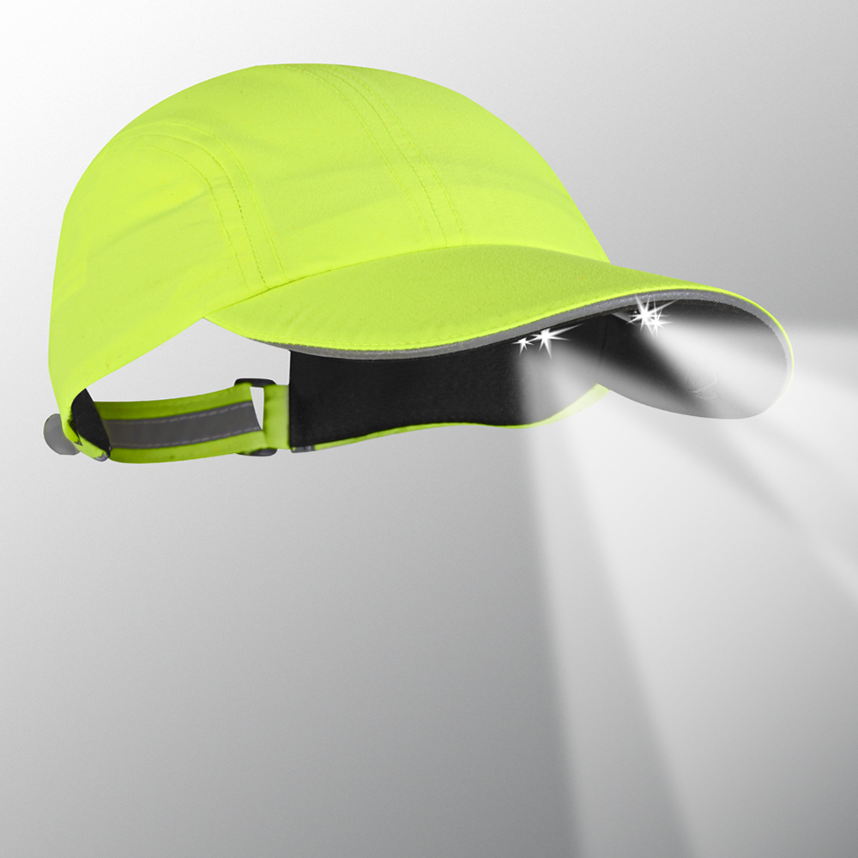
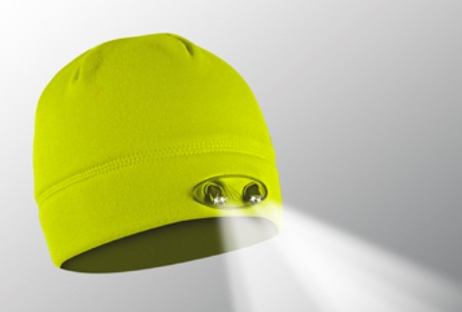
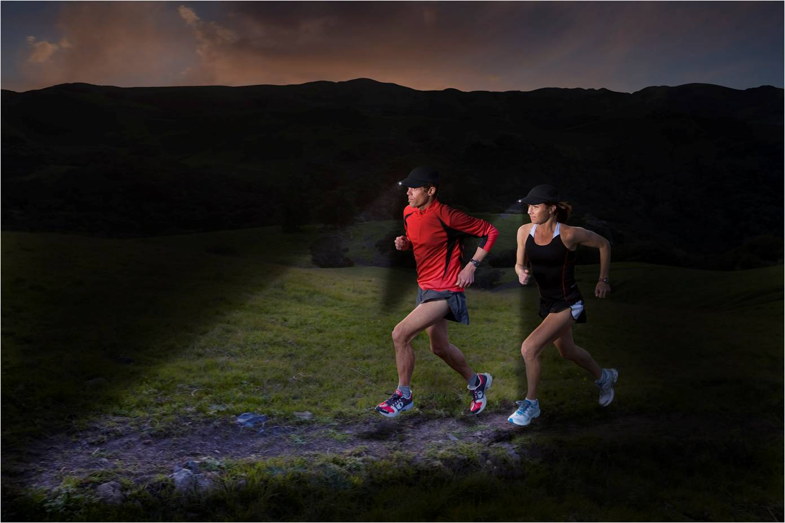

VISIT OUR WEBSITE WWW.PANTHERVISIONPROMO.COM
TO SEE THE FULL LINE OF LIGHTED PRODUCTS
OR CALL 847.783.5900 x 116 FOR MORE INFORMATION

VISIT OUR WEBSITE WWW.PANTHERVISIONPROMO.COM
TO SEE THE FULL LINE OF LIGHTED PRODUCTS
OR CALL 847.783.5900 x 116 FOR MORE INFORMATION

Trying to start a wellness program?
There are numerous benefits that accompany a
well-run wellness program. These programs save
money for the company by reduced absenteeism and promote greater productivity. They encourage
employees to be healthier, stronger and be better
able to handle their work/life balance.

Some of the best training happens
before the sun rises and after it sets.

For walking or running, The POWERCAPS®
offer the ultimate hands-free flashlight”,
high & low beam directional lighting for seeing the trail ahead along with where you place your feet.

Quick dry, light weight microfiber material and
reflective trim in the sandwich and back keyhole on the caps. The beanies feature a moisture wicking
liner. Easy on/off switch provides 48 lumens of useful lighting. Included batteries are easily replaceable.

Add your logo to light up your brand!

VISIT OUR WEBSITE WWW.PANTHERVISIONPROMO.COM
TO SEE THE FULL LINE OF LIGHTED PRODUCTS
OR CALL 847.783.5900 x 116 FOR MORE INFORMATION

Type your information here
Stealth 2575 Runners in Black
PR4-142
Stealth 3555 beanie in yellow
WB-5529
Runners/walkers will see and be seen
Stealth 2575 Runners in Yellow
PR4-177
WELLNESS PROGRAM SOLUTION

VISIT OUR WEBSITE WWW.PANTHERVISIONPROMO.COM
TO SEE THE FULL LINE OF LIGHTED PRODUCTS
OR CALL 847.783.5900 x 116 FOR MORE INFORMATION

VISIT OUR WEBSITE WWW.PANTHERVISIONPROMO.COM
TO SEE THE FULL LINE OF LIGHTED PRODUCTS
OR CALL 847.783.5900 x 116 FOR MORE INFORMATION

VISIT OUR WEBSITE WWW.PANTHERVISIONPROMO.COM
TO SEE THE FULL LINE OF LIGHTED PRODUCTS
OR CALL 847.783.5900 x 116 FOR MORE INFORMATION

ASI 75825 SAGE 68668 PPAI 318255

VISIT OUR WEBSITE WWW.PANTHERVISIONPROMO.COM
TO SEE THE FULL LINE OF LIGHTED PRODUCTS
OR CALL 847.783.5900 x 116 FOR MORE INFORMATION

VISIT OUR WEBSITE WWW.PANTHERVISIONPROMO.COM
TO SEE THE FULL LINE OF LIGHTED PRODUCTS
OR CALL 847.783.5900 x 116 FOR MORE INFORMATION

